Lab 2: demonstrate how instances in public subnet can talk to internet and instances in private subnet cannot

Task1: create your ec2 in public and private subnet

* Ssh login both ec2

Theory:

### Compute Service: A compute service gives you online computers to run programs, apps, or websites. You don’t need to buy or manage real computers; the service does it for you.

### Amazon EC2 (Elastic Compute Cloud):Amazon EC2 is an online computer you can use to run apps or websites. You can choose how powerful the computer should be and change it anytime.

### Security Group: A security group is like a wall around your online computer (EC2). It decides what can come in and go out, keeping your computer safe.

Architecture design for ec2 in public subnet and private subnet:

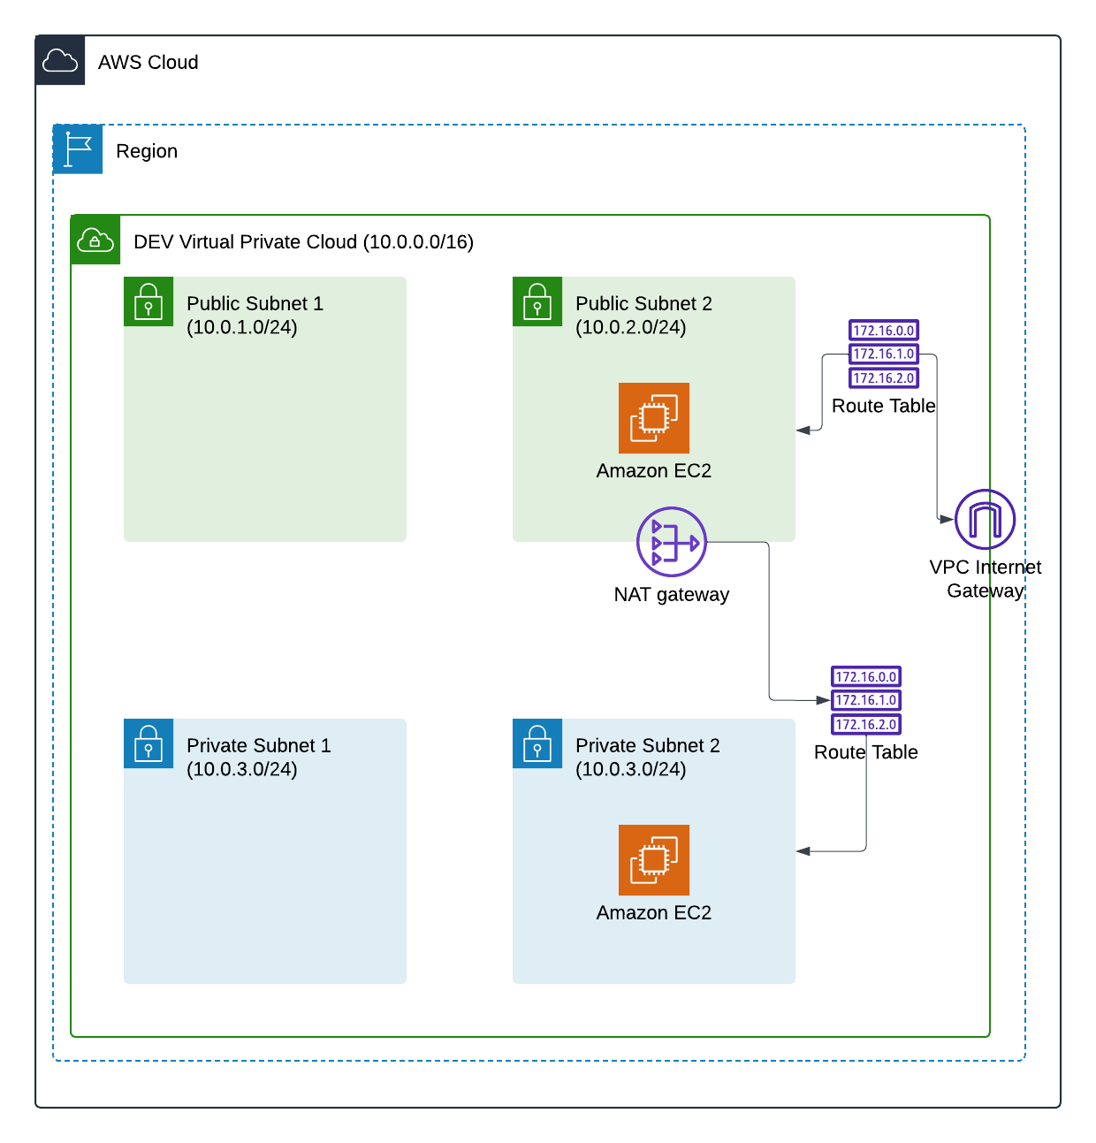

**Steps for making ec2 in public subnet :**

Step 1: go to ec2 and click lunch instances. Enter name of ec2, choose OS like Ubunutu or linux. Create new key pair. Go to network setting. Click edit. Select vpc and public subnet and enable auto assign public IP.click add security rules. Enter HTTP and in source enter anywhere.at the end click lunch instance.

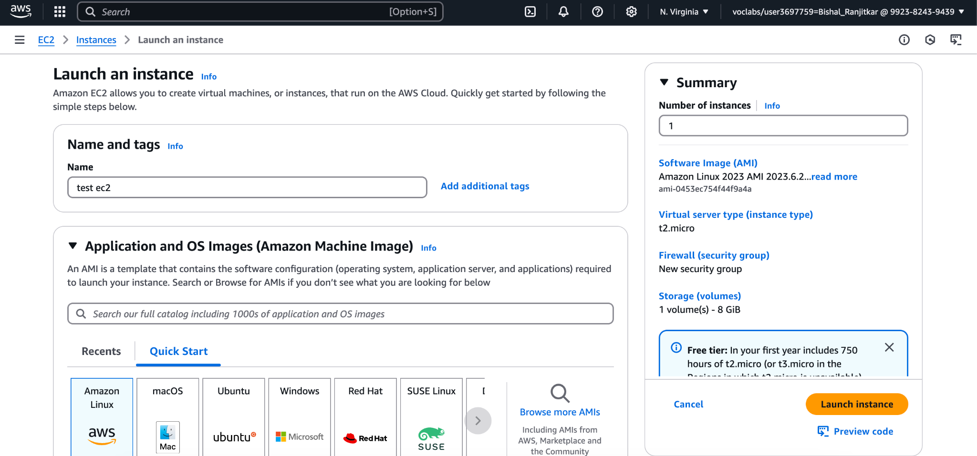

Step 2: go to terminal type chmod 400 "test-key.pem" for changing permission to read only and type ssh -i /path/to/your-key.pem ec2-user@public-ip-address

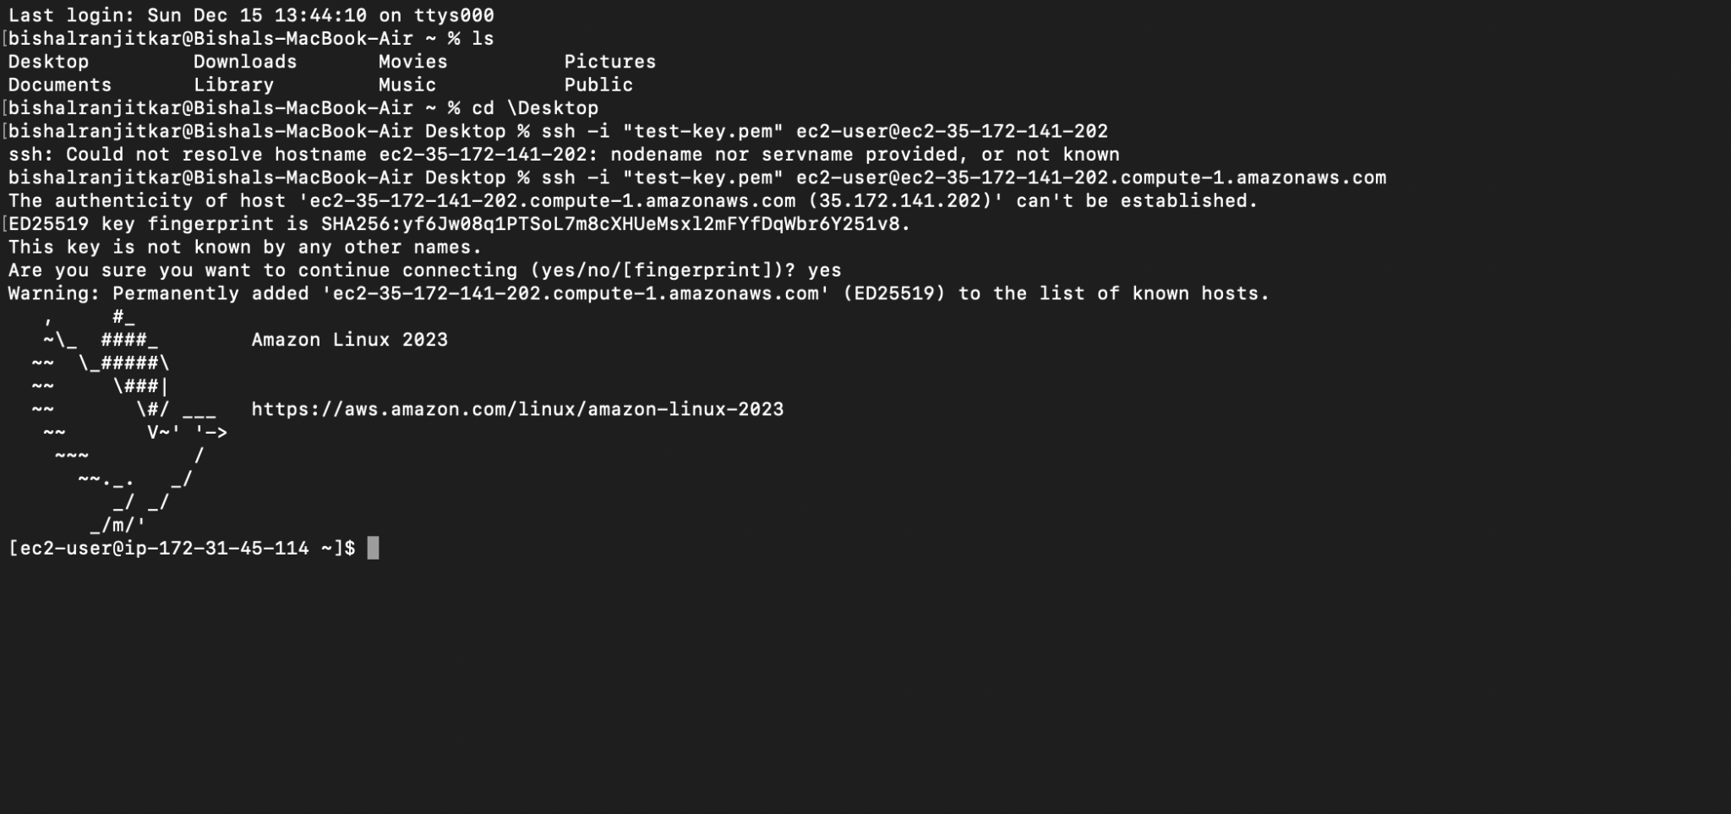

**Steps for making ec2 in private subnet :**

Step 1: go to ec2 and click lunch instances. Enter name of ec2, choose OS like Ubunutu or linux. Create new key pair. Go to network setting. Click edit. Select vpc and private subnet and disable auto assign public IP.click add security rules. Enter HTTP and in source enter anywhere.at the end click lunch instance.

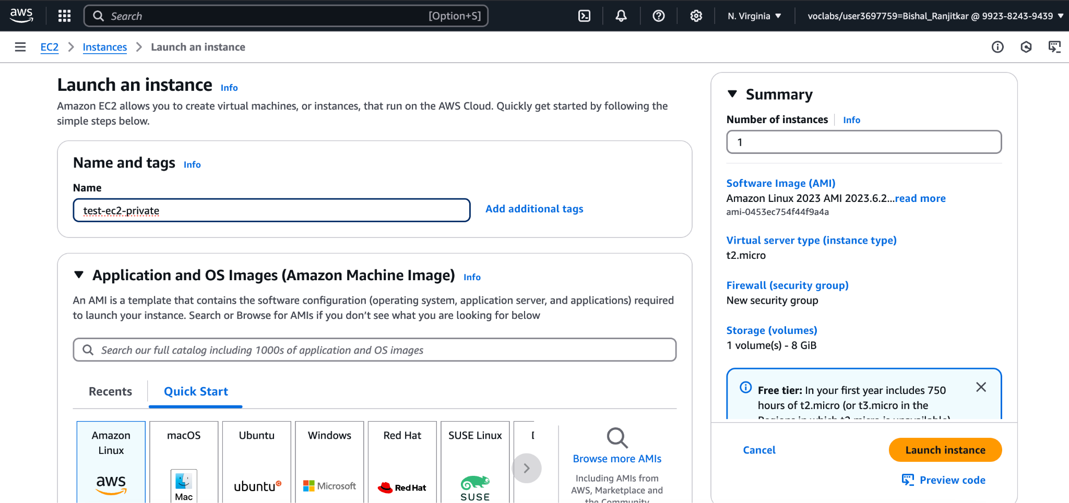

Step 2: go to terminal and Copy Your Private Key to the Public EC2 Instance.

scp -i /path/to/your-key.pem /path/to/your-key.pem ec2-user@public-ip-address:/home/ec2-user/ Then Set Permissions for the Key File on the Public EC2 Instance chmod 400 /home/ec2-user/your-key.pem and Connect to the Private EC2 Instance.ssh -i /home/ec2-user/your-key.pem ec2-user@private-ip-address



### **Conclusion**

We created two ec2. One in public subnet and another in private subnet and learned how we can access the the internet with oth the ec2 with the help of terminal by doing ssh login.